Launch an ec2 instance under a default subnet and VPC using terraform template

Solution:

Created an AMI

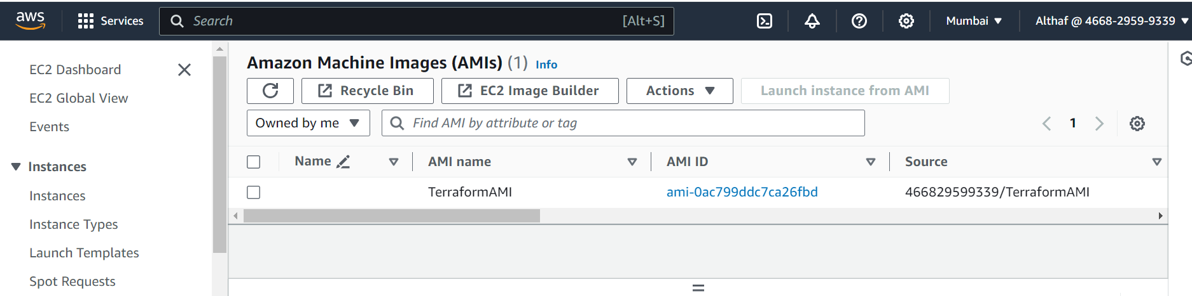

Created an Key pair

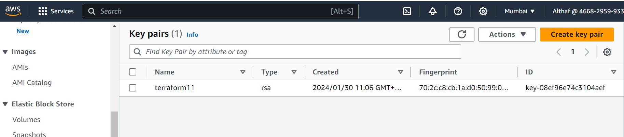

**Written an Terraform Script to to create infra**

**provider "aws" {**

**region = "ap-south-1"**

**}**

**data "aws_vpcs" "default" {}**

**data "aws_subnet" "default" {**

**vpc_id = data.aws_vpcs.default.ids[0]**

**availability_zone = "ap-south-1a"**

**}**

**resource "aws_instance" "example_instance" {**

**ami = "ami-0ac799ddc7ca26fbd"**

**instance_type = "t2.micro"**

**key_name = "terraform11"**

**subnet_id = data.aws_subnet.default.id**

**tags = {**

**Name = "ExampleInstance"**

**}**

**}**

Terraform init

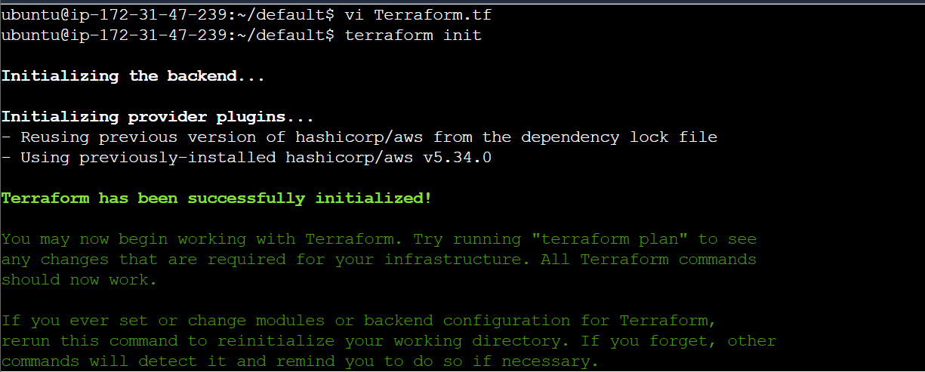

Terraform Plan

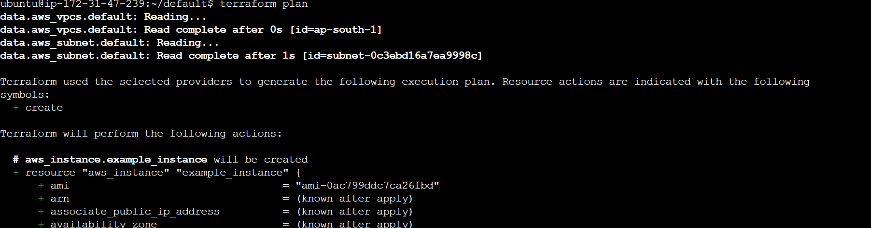

Terraform apply

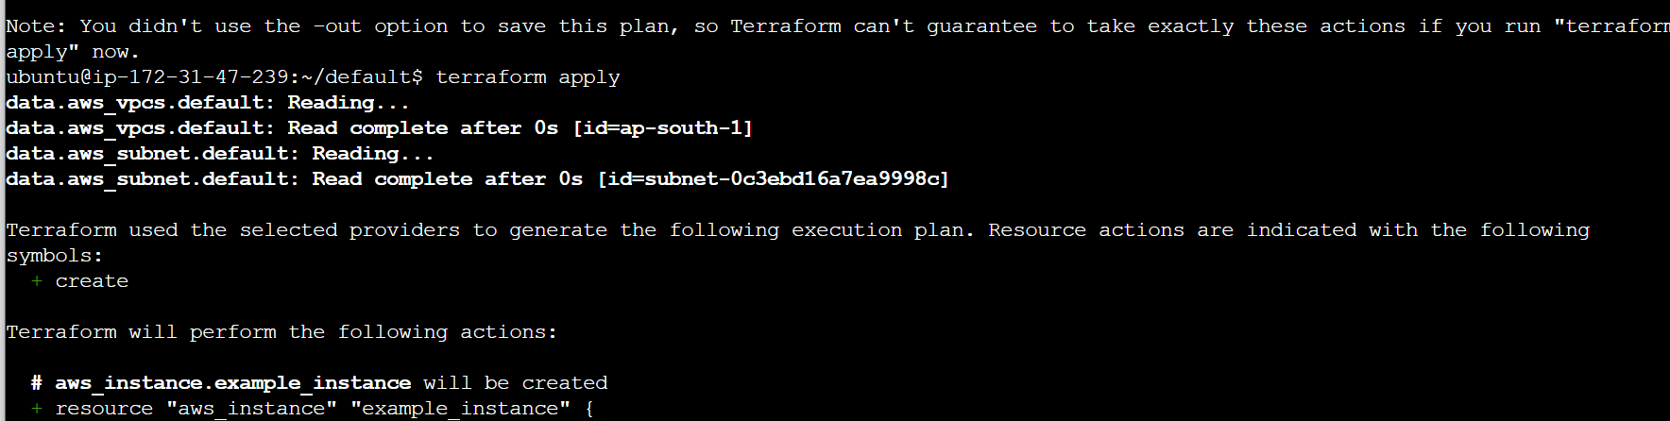

Infra has been created

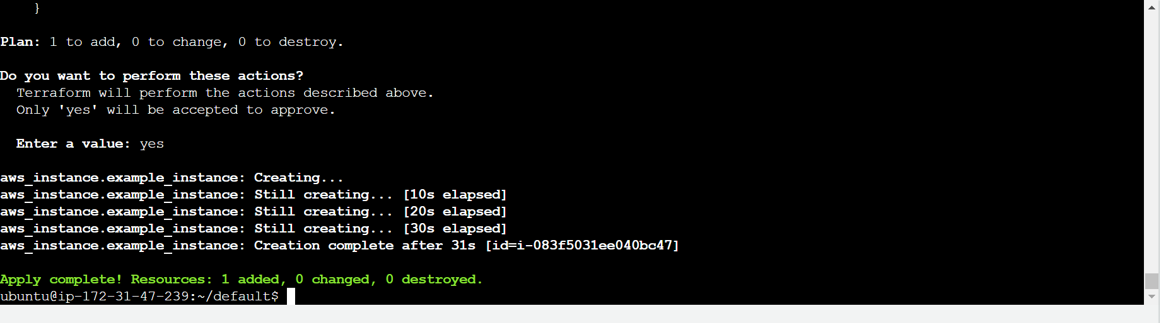

Outputs:

Ec2 is created using Default VPC and Subnet by Terraform script

